**User guide for the Sourcing Table App**

Table of contents :

**Introduction** 2

**I/ How to navigate the application?** 3

**II/ The “Home” page** 3

**III/ The “Sourcing Table” page** 4

**1)** **The “Import data” button** 4

**2)** **Dashboards tabs** 5

a) Operationnal roles 5

b) Functional roles 9

**3)** **Simulation tabs** 10

**4)** **Mass loading TOPs** 10

**IV/ The “Archive” page** 11

**1)** **Select an archive** 11

**2)** **View data from the selected archive** 12



# **Introduction**

The Sourcing Table App is a web application designed to visualize the workload and workforce of the CSO platform and to make insourcing adjustments.

It is composed of two main pages in addition to the home page:

* The "Sourcing Table" page corresponds to the creation of a baseline and the realization of insourcing adjustments (for security reasons, access to this page is password-restricted to specific persons)
* The "Archives" page allows you to view and download the data of a completed baseline. A baseline is considered completed when the TOPs have been inserted into RDPM.

In this guide you will find the different features of the application and their uses.

# **I/ How to navigate the application?**

To navigate through the different pages of the application, a navigation bar is available at the top of the page. You need to click on the tabs on the right of the navigation bar to go to the corresponding page. The curently selected page will be highlighted.



To navigate through the different tabs composing a page, you will find a vertical navigation bar on the left of the page.

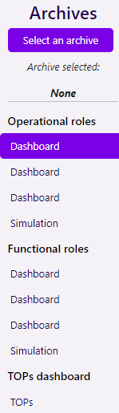

At the top of the page, you will find the name of the page you are currently on, followed by the tabs that make it up.

Click on the wanted tab to go to it. The currently selected tab will be highlighted.

The content of the page will change according to your selection.

# **II/ The “Home” page**

The home page contains a short description of the application and its usage. You can also download the user guide from this page.

# **III/ The “Sourcing Table” page**

The "Sourcing Table" page is where you can view data for the various departments making up the CSO platform, make external workforce adjustments in these departments (called TOPs), and then extract and export these adjustments. The data available are:

**-Workload (in FTE)**

**-Headcounts (in FTE):** represents the FTE availability of internal resources.

**-110A committed (in FTE):** represents the FTE availability of external contractors.

**-AD10 committed (in FTE):** represents the FTE availability of external interim workers.

**-110A + AD10 TOP adjustments (in FTE):** represents the FTE availability of the TOPs (i.e., the external workforce adjustments).

**-Insourcing contractors (in FTE):** represents the FTE availability of external resources. It is equal to the sum of AD10 committed, 110A committed and TOPs adjustments.

**-In-House workforce (in FTE):** represents the total FTE availability of internal and external resources.

**-Internal workload coverage (in %):** represents the rate of workload coverage by the total workforce (in-house workforce).

**-Internal flexibility (in %):** represents the ratio of external resources (insourcing contractors) to the total workforce (in-house workforce).

**-Internal workload gap (in FTE):** represents the difference between the workload and the total availability (in-house workforce).

**Access to this page is restricted by a password to limit access to those responsible for running the baselines.**

The “Sourcing Table” page is composed of several tabs which are presented below.

## **The “Import data” button**

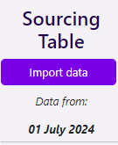

To import new data into the application during a new baseline, first click on the "Import data" button.

Then go to the Tableau report from the link on the application page (highlighted in blue) and download the Resource extract and the workload extract in Excel format for the live data.

Then load the two extracts in their respective area and click on "Import data". The data will then be loaded into the application. You can, if you wish, keep the old TOPs made during the previous baseline and reapply them by default on the lines concerned by checking the line "Keep the TOPs from the last import".

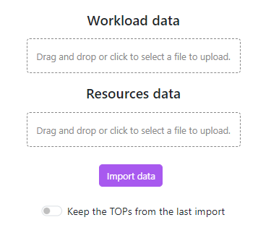

## **Dashboards tabs**

### Operationnal roles

You will find three different dashboards showing data for the current year, the next year and the year after that respectively. All tabs are identical, only the data they contain varies. You can scroll through the different rows using the scroll wheel or the scroll bar on the right. You can resize a column by clicking and dragging the vertical bar located to the right of it. You can also double-click on it to automatically resize the column according to the contents of its cells.

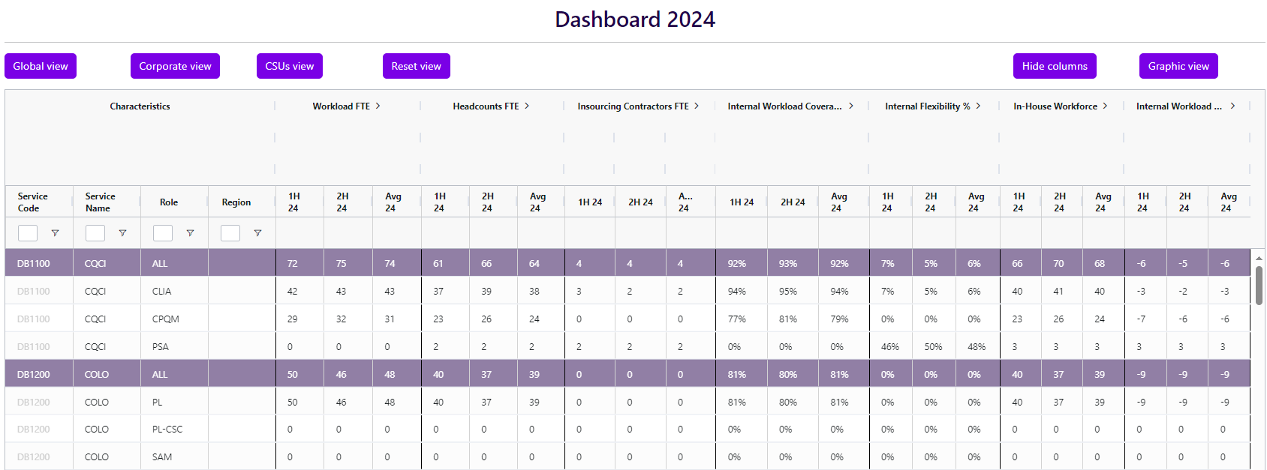

To make it easier to view and understand the data, some rows are colored in a particular way. You will find below the equivalence of each color.



- Corresponds to a service's global data, including all roles for a specific region.

 - Corresponds to the global data of a service, including all roles and all regions, in the case where a service contains different data for different regions.

- Corresponds also to the global data of a department, including several services. For example, the “Total Trial Operations” department defined by the code DB15 includes DB1500, DB1501 and DB1502 services.

- Corresponds to the global data of a group. There are currently two groups, “Corporate Departments” (includes all services except those whose code begins with DB17) and “CSUs” (includes all services whose code begins with DB17).



- Corresponds to the global data of the CSO platform.

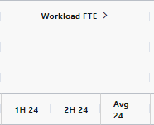Each dashboard is composed of 8 columns presenting data by semester or quarter. You can change the temporality of the data displayed by clicking on the arrow as shown in the image below.

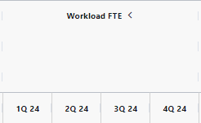

The "Insourcing Contractors FTE" column can be expanded by clicking on the arrow next to "Details" to view the various data making up the insourcing contractor field. (i.e., 110A committed, AD10 committed and 110A +AD10 TOPs).

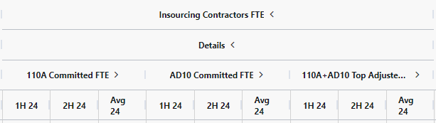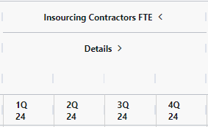

You can view aggregated data by selecting multiple rows on the dashboard. To select several rows, hold down the Ctrl key on your keyboard and click on the desired rows. If you click on a row without holding down the ctrl key, only the clicked rows will be selected. You can also select a range of adjacent rows by selecting the first row of that range and, while holding down the shift key, clicking on the last row. All rows between these two rows will then also be selected. Selected rows will be highlighted in blue.

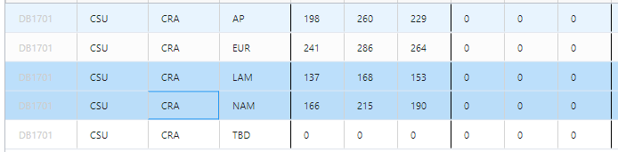

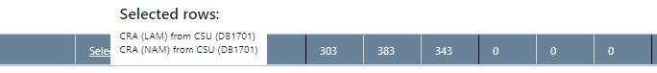A new row will then appear at the bottom of your table, displaying the aggregated data corresponding to the selected row. You can check the selected rows by hovering your mouse cursor over "Selected Rows". A tooltip will appear, informing you of the rows currently selected.

In the "Characteristics" column, you can apply filters of your choice to the “Service code”, “Service Name”, “Role” and “Region” fields. To do this, simply click on the white square or the symbol next to it and enter the filter.

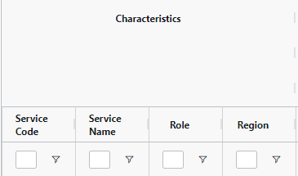

By clicking on the symbol, you can also customize the filter by selecting the conditions of your choice and apply several filters at once to the same column.

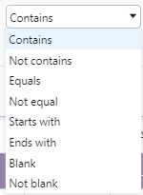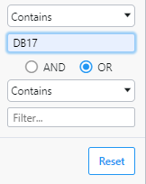

You can also quickly apply a filter using one of the three views currently available. To do this, simply click on the button corresponding to the desired view, and the appropriate filters will be applied automatically.



Here are the three possible views:

-**Global view:** Shows the global data, i.e., service and department data without the detail of each role.

-**Corporate view:** Shows the data related to the “Corporate Departments” group.

-**CSUs view:** Shows the data related to the “CSUs” group.

The “Reset view” button can be used to quickly reset all the active filters.

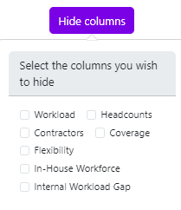

You can hide the columns of your choice on the dashboard by clicking on the "Hide columns" button and selecting the columns you wish to hide. To display them again, simply deselect them.

The "Graphic view" button can be used to display data in graphical form. Click on the button, select one or more timeframes and one or more services. You will then be able to view the workload, the workforce and its details (headcounts and contractors), the coverage rate and the flexibility rate in a very simple way. You can scroll through the different rows using the scroll wheel or the scroll bar on the right.

To exit this view, click on the cross at top right or click on the close button at bottom right. You can also press the Esc key on your keyboard.



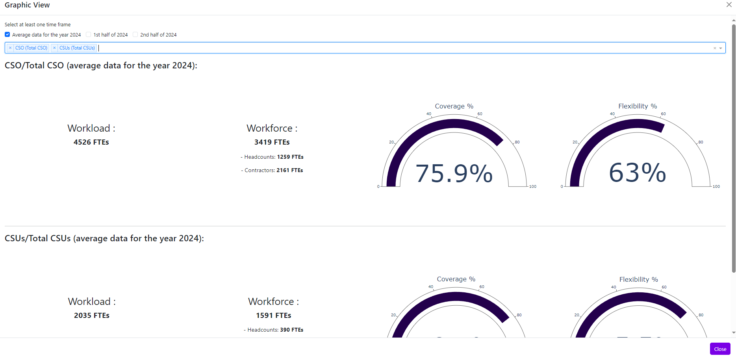

### Functional roles

The dashboard tabs for functional roles are like those for operational roles. The only difference is that there are fewer columns and it's not possible to have a graphical view of the data.

## **Simulation tabs**

The simulation tabs are identical whether for operational roles or functional roles.

You can view and edit the data for any combination you choose using the drop-down bars above the data grid.



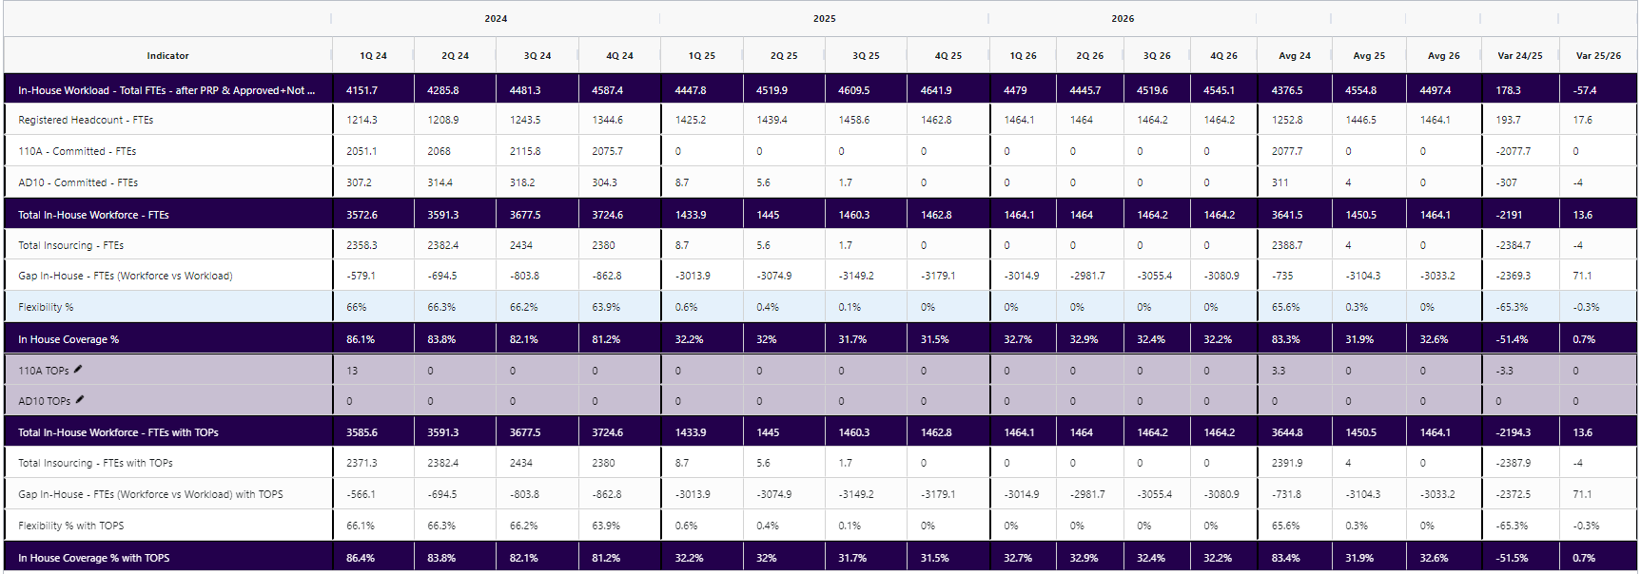

You can then make adjustments for the combination of your choice by entering values ​​in the lines "110A TOPs" and "AD10 TOPs" highlighted in light purple. Please note that you cannot make an adjustment on a service group or if any of your selection bars have the value "ALL".

Remember to save regularly using the "Save" button located at the top of the page.

## **Mass loading TOPs**

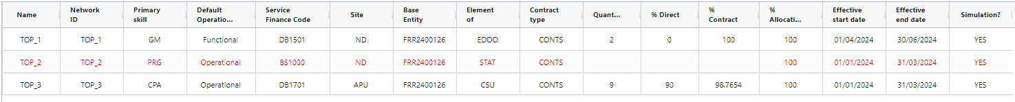After you have saved the different TOPs performed, these will appear in the "Mass loading TOPs into RDPM" tab. These will already be formatted in the format expected by RDPM and completed with the various expected information.

If a line appears in red, it means that there is no operational rate associated with this combination at the moment. The user is then prompted to click on the "Set operational rate" button located at the top right of the page and enter and save the missing operational rate(s). Once all the missing operational rates have been processed, you can then click on the "Export" button which will download a CSV file to your computer. This CSV file must be sent to BSM so that they can import the TOPs into RDPM.

**You may get values ​​in the ”% Contract column” that seem strange to you at first (value with several decimal places). This is normal and is due to the way the application makes the connection between the TOPs entered in the "Simulation" tabs (expressed in FTEs) and the TOPs currently entered in RDPM (which are expressed in heads).**

# **IV/ The “Archive” page**

## **Select an archive**

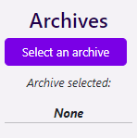

To select an archive, please click on the "Select an archive" button. You will then have the choice in a drop-down bar between all the baselines completed within the application. Select the one you want and click on the "Load the archive" button. The data corresponding to the archive will then be loaded into the application.

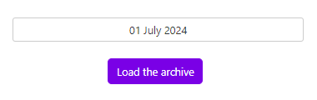

## **View data from the selected archive**

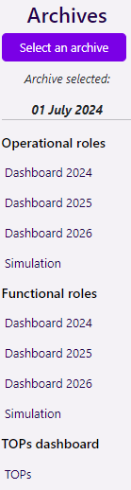

You can then view the data related to the selected archive using the different tabs located in the side navigation bar.

All these tabs are similar to those present in the "Sourcing Table" page, except that the archive data is read-only.

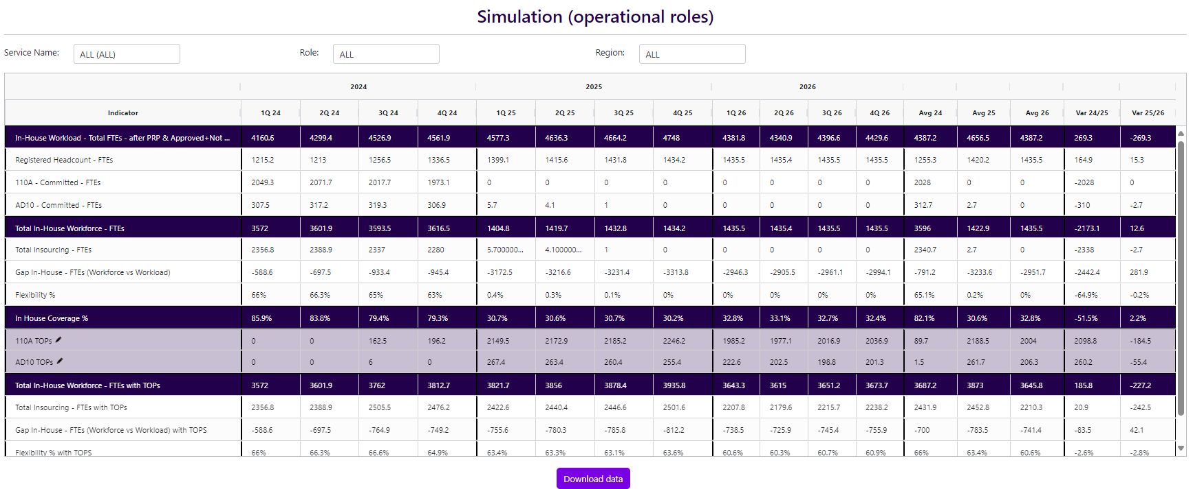You can download baseline data in Excel format using the two simulation tabs. Each tab will return data related to its role type (operational or functional). To do this, go to the simulation tab of your choice and click on the "Download the data" button located below the data grid.

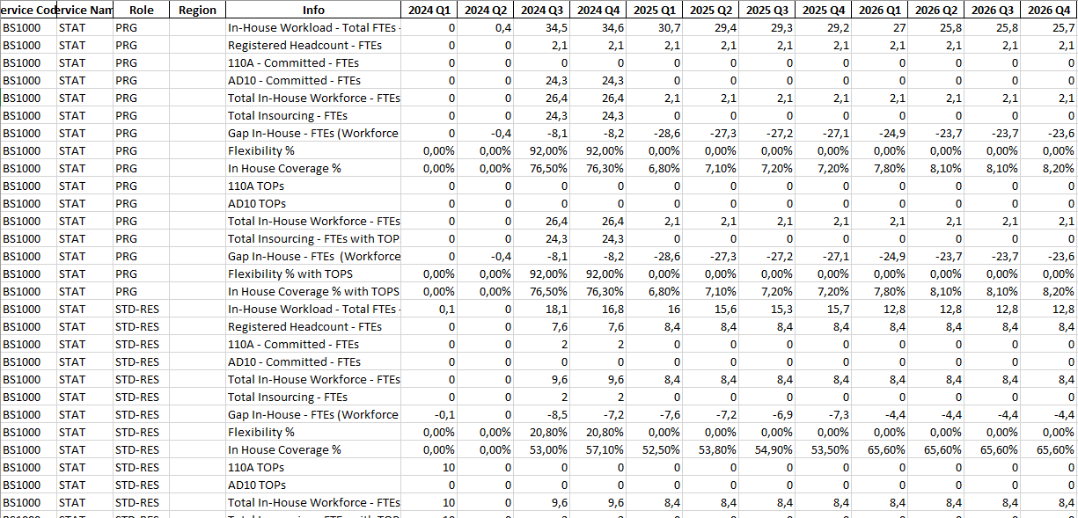

You will then get an Excel file similar to this. The "Info" column indicates the type of data contained on the row.